Experiment 2

Student Name: Nikhil Kumar UID: 25MCI10036
Branch: MCA (AI/ML) Section/Group: 25MAM-1(A)
Semester: 2-SEM Date of Performance: 13/01/2026
Subject Name: Technical Training - 1 Subject Code: 25CAP-652

- Aim of the Session:

To implement and analyze SQL SELECT queries using filtering, sorting, grouping, and aggregation concepts in PostgreSQL for efficient data retrieval and analytical reporting.

- Software Requirements:
- PostgreSQL
- pgAdmin
- Windows Operating System

- Objectives of the Session:
- To retrieve specific data using filtering conditions
- To sort query results using single and multiple attributes
- To perform aggregation using grouping techniques
- To apply conditions on aggregated data
- To understand real‑world analytical queries commonly asked in placement interviews

- Procedure of the practical
- Create a sample table representing Employee details
- Insert realistic records into the table
- Retrieve filtered data using WHERE clause
- Sort query results using ORDER BY clause
- Group records using GROUP BY clause
- Apply conditions on grouped data using HAVING clause
- Analyze execution order of WHERE and HAVING clauses

- Practical / Experiment Steps

Step 1: Database and Table Preparation
- Start the PostgreSQL server.
- Open the PostgreSQL client tool.
- Create a database for the experiment.
- Prepare a sample table representing customer orders containing details such as customer name, product, quantity, price, and order date.
- Insert sufficient sample records to allow meaningful analysis.

Purpose: To create a realistic dataset for performing analytical queries.

Step 2: Filtering Data Using Conditions
- Execute data retrieval operations to display only those records that satisfy specific conditions, such as higher-priced orders.
- Observe how filtering limits the number of rows returned.

Observation: Filtering reduces unnecessary data processing and improves query efficiency.

Step 3: Sorting Query Results
- Retrieve selected columns from the table and arrange the output based on numerical values such as price.
- Perform sorting using both ascending and descending order.
- Apply sorting on more than one attribute to understand priority-based ordering.

Observation: Sorting is essential for reports, rankings, and ordered displays.

Step 4: Grouping Data for Aggregation
- Group records based on a common attribute such as product.
- Calculate aggregate values like total sales for each group.
- Analyze how multiple rows are combined into summarized results.

Observation: Grouping transforms transactional data into analytical insights.

Step 5: Applying Conditions on Aggregated Data
- Apply conditions on grouped results to retrieve only those groups that satisfy specific aggregate criteria.
- Compare the difference between row-level filtering and group-level filtering.

Observation: Conditions applied after grouping allow refined analytical reporting.

Step 6: Conceptual Understanding of Filtering vs Aggregation Conditions
- Analyze scenarios where conditions are incorrectly applied before grouping.
- Correctly apply conditions after grouping to avoid logical errors.

Observation: Understanding execution order prevents common SQL mistakes frequently tested in interviews.

- Input / Output details and Screenshots:
- Creating sample table and inserting records.

Input:

CREATE TABLE employee_details (

emp_id SERIAL PRIMARY KEY,

emp_name VARCHAR(50),

department VARCHAR(50),

salary NUMERIC(10,2),

experience INT,

joining_date DATE

);

INSERT INTO employee_details (emp_name, department, salary, experience, joining_date) VALUES

('Amit', 'IT', 65000, 5, '2019-06-10'),

('Neha', 'HR', 42000, 3, '2021-02-15'),

('Rohan', 'Finance', 58000, 6, '2018-09-20'),

('Priya', 'IT', 72000, 7, '2017-01-05'),

('Kunal', 'Marketing', 45000, 4, '2020-07-12'),

('Sneha', 'HR', 48000, 5, '2019-11-18'),

('Vikram', 'Finance', 80000, 10, '2015-03-25');

SELECT * FROM employee_details;

Output:

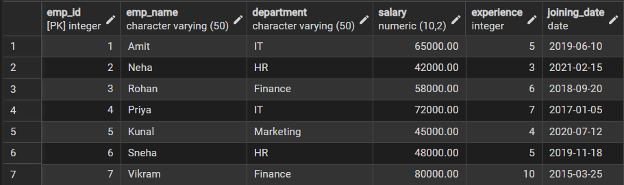

Displaying all records from employee_details table.
- Filtering data using WHERE clause

-- Employees with salary greater than 50000

SELECT *

FROM employee_details

WHERE salary > 50000;

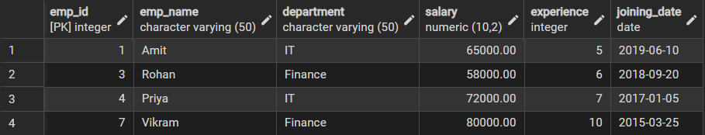

-- Employees from IT department

SELECT emp_name, department, salary

FROM employee_details

WHERE department = 'IT';

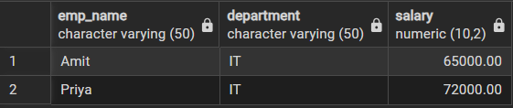
- Sorting query results using ORDER BY clause

-- Sort employees by salary (ascending)

SELECT emp_name, department, salary

FROM employee_details

ORDER BY salary ASC;

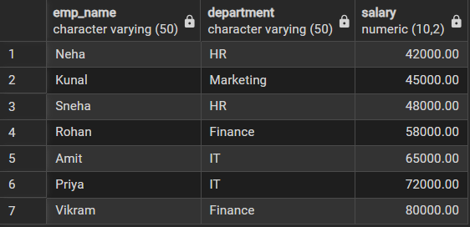

-- Sort employees by experience (descending)

SELECT emp_name, department, experience

FROM employee_details

ORDER BY experience DESC;

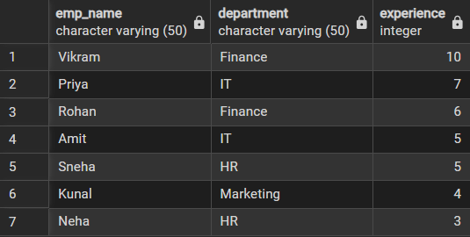
- Grouping data for aggregation.

-- Average salary per department

SELECT department, AVG(salary) AS avg_salary

FROM employee_details

GROUP BY department;

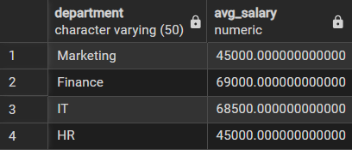

-- Number of employees in each department

SELECT department, COUNT(emp_id) AS employee_count

FROM employee_details

GROUP BY department;

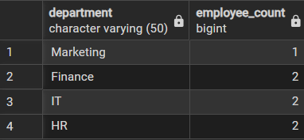
- Applying conditions on aggregated data using HAVING clause.

-- Departments with average salary greater than 50000

SELECT department, AVG(salary) AS avg_salary

FROM employee_details

GROUP BY department

HAVING AVG(salary) > 50000;

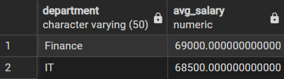

-- Departments having more than or equal to 2 employees

SELECT department, COUNT(emp_id) AS employee_count

FROM employee_details

GROUP BY department

HAVING COUNT(emp_id) >= 2;

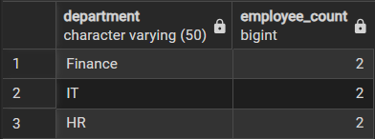
- Using WHERE and HAVING together

-- Display departments where:

-- 1. Only employees with more than 4 years of experience are considered (row-level filtering)

-- 2. The average salary of those employees is greater than 60000 (group-level filtering)

SELECT department, AVG(salary) AS avg_salary

FROM employee_details

WHERE experience > 4 -- Filters rows before grouping

GROUP BY department -- Groups records department-wise

HAVING AVG(salary) > 60000; -- Filters groups after aggregation

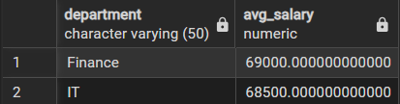

- Learning Outcomes (What I have learned):
- Students understand how data can be filtered to retrieve only relevant records from a database.
- Students learn how sorting improves readability and usefulness of query results in reports.
- Students gain the ability to group data for analytical purposes.
- Students clearly differentiate between row-level conditions and group-level conditions.
- Students develop confidence in writing analytical SQL queries used in real-world scenarios.
- Students are better prepared to answer SQL-based placement and interview questions related to filtering, grouping, and aggregation.

